Contents

Task 1 2

1. Script to create folders 2

2. List down directory structure 2

ls commands 2

Tree command 3

3. List down contents of the folder 4

4. Making program as executable 4

5.Moving file from one folder to another 5

6. Delete options 5

Task 2 6

code 6

Output screenshots for task 2 7

Task 3 10

Code 10

Output 11

# Task 1

1. Script to create folders (Kindly refer the bash file named Createfolder.sh)

The command I used here is **mkdir -p ~/Desktop/CSP2101/Portfolio1/{Task1,Task2,Task3}**

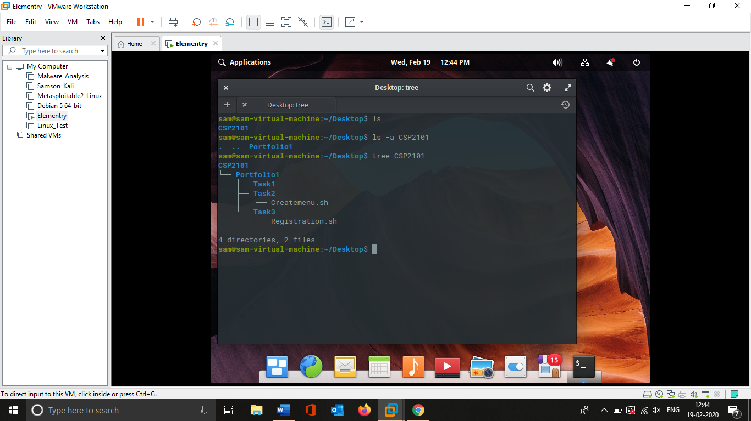

This command will create folders under the Desktop directory. Based on the requirement the user can change the source directory by replacing it.

## 2. List down directory structure

There are more than 1 command that can be used to list down the directory structure.

### ls commands

The first command is **ls** which shows only the file/directory names.

ls -a will display even the hidden files

ls -ld * is to list about the directory

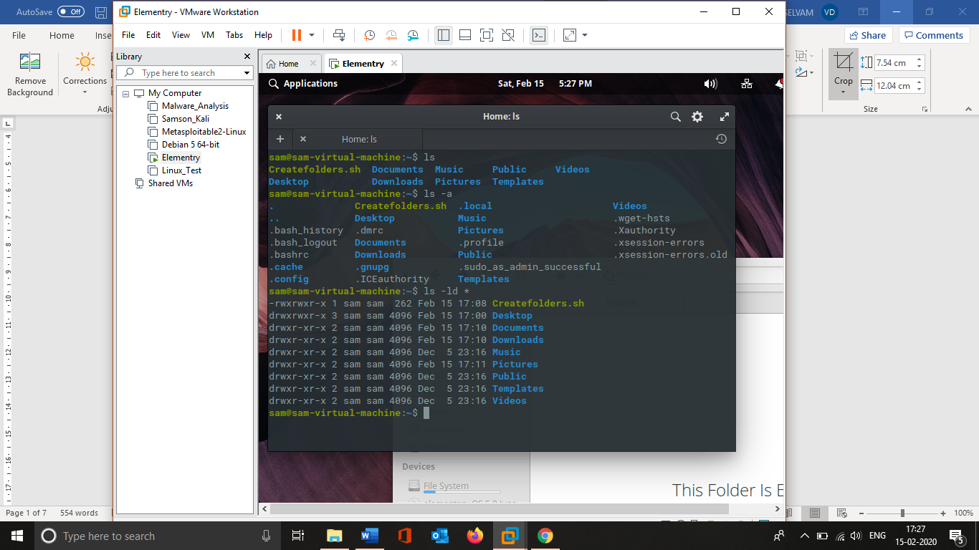

Screenshot 1 Usage of ls commands

### Tree command

It’s basically an additional utility which needed to installed manually. Using tree command will display the structure in the form of a tree.

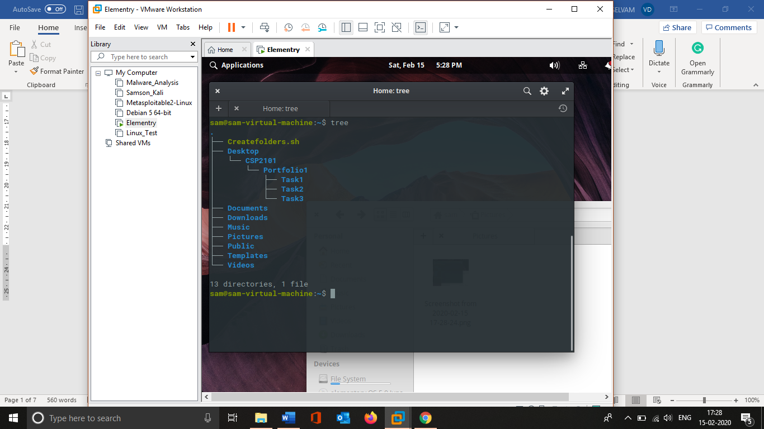

Screenshot 2 Usage of Tree command

## 3. List down contents of the folder

Commands that will list all the contents of your folder

Same as directory listing the **ls** commands can be used to list all the content of a folder.



Screenshot 3 List down the contents of folder

## 4. Making program as executable

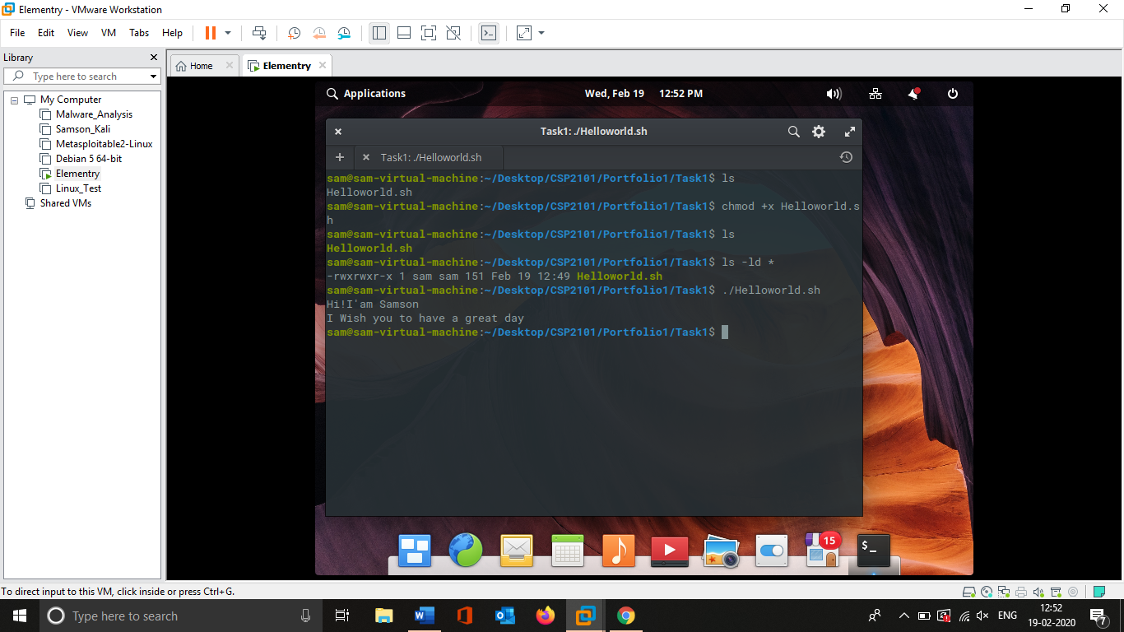

Screenshot 4 Making program as executable

The commands to make a program executable is chmod +x or chmod +777. Here I have used chmod +x and we can see that the program now has execution rights. After that I executed the program to display the given message.

## 5.Moving file from one folder to another

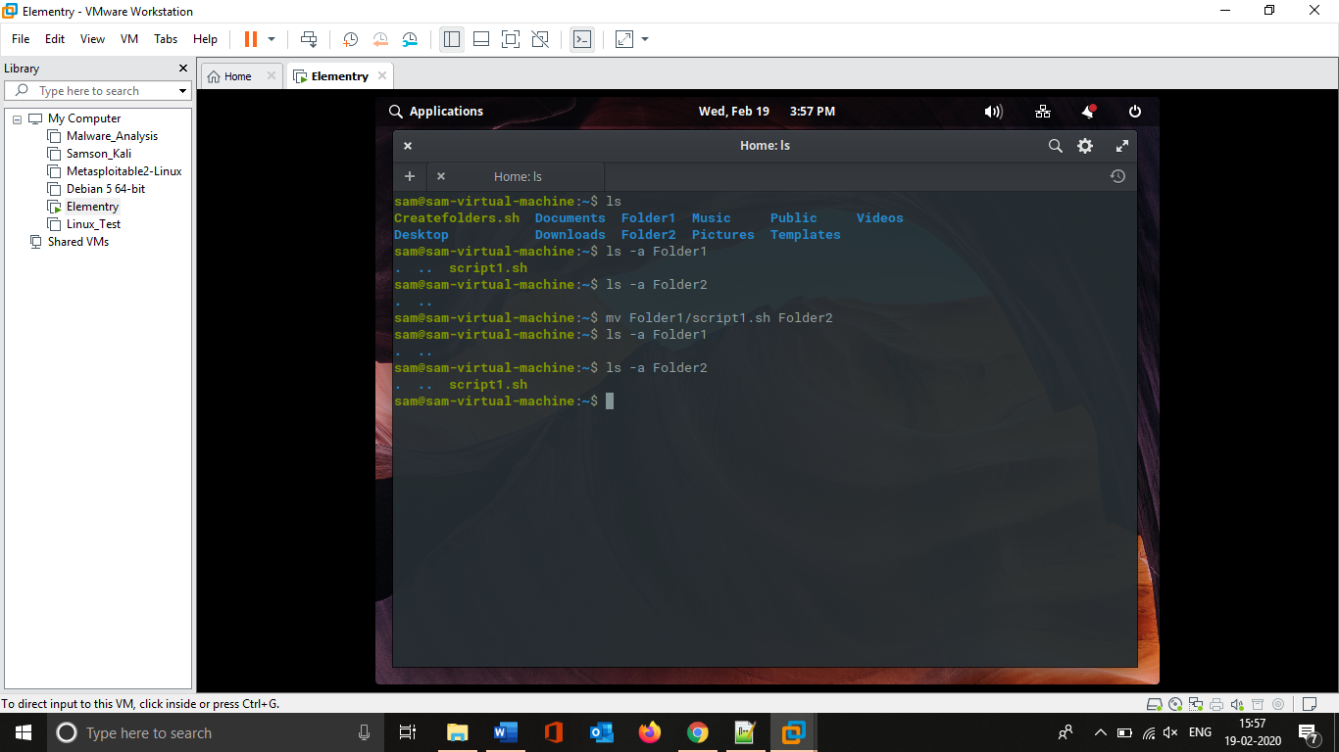

Screenshot 5 Move file from one folder to another

The command to move a file from one folder to another is using **mv** command. For the given task the command is **mv Folder1/script1.sh Folder 2**. Above screenshot we can see that at first a file names script1.sh is available in Folder1 and Foler2 is empty. After using the mv command we can see that the file has been moved from folder1 to folder2.

## 6. Delete options

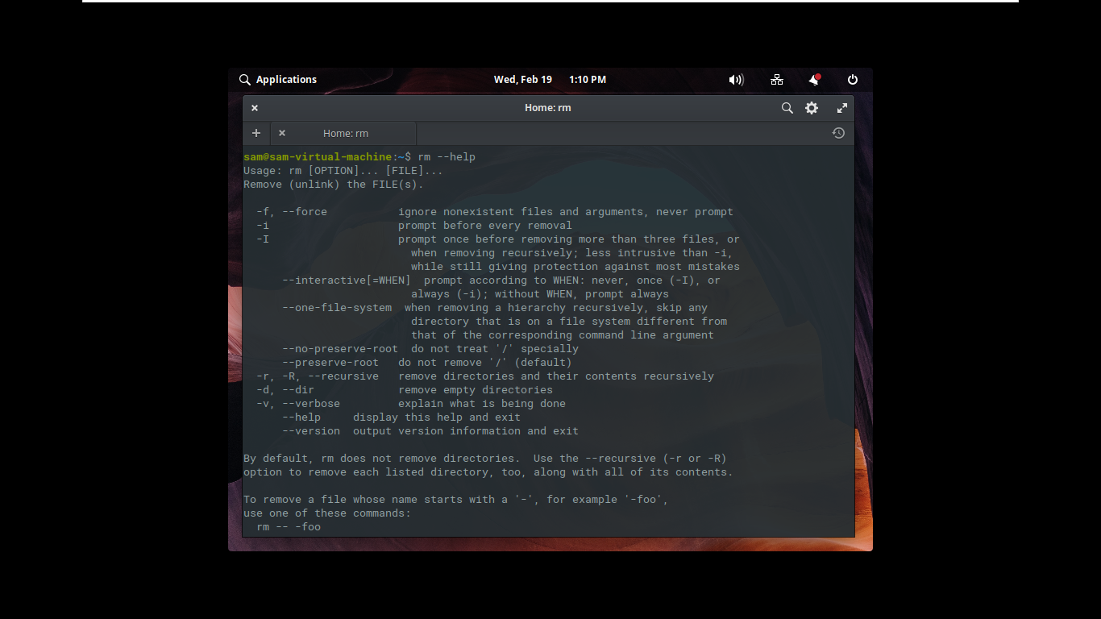

Screenshot 6 Different delete options

**rm** is a command used to delete the files and folders. The various options available are can be found using the command **rm – -help** in terminal

# Task 2

## code

#!/bin/bash

#Author : Samson

#Discription : A sample menu display, Bash script

#Displaying menu items to choose

echo Welcome To Display Menu

echo ==========================

echo 1.Register User

echo 2.Users Details

echo 3.Edit User

echo 4.Save User

echo 5.Change Password

echo 6.Print Report

echo 7.Exit

echo "Enter Your choice as (Eg : ./Createmenu.sh 1)."

if [ -v $1 ]; then

exit

fi

echo ==========================

#color code Assigning

White='\033[1;37m'

Gray='\033[90m'

Magneta='\033[35m'

Yellow='\033[33m'

Blue='\033[34m'

Green='\033[32m'

Cyan='\033[36m'

Red='\033[31m'

case $1 in

1)

echo -e "${White}Hey You Are Registered";;

2)

echo -e "${Gray}Details has been saved";;

3)

echo -e "${Magneta}Edit Saved";;

4)

echo -e "${Yellow}User has been Saved";;

5)

echo -e "${Blue}Password has been changed";;

6)

echo -e "${Green}Report has been printed";;

7)

echo -e "${Cyan}Thank You";;

*)

echo -e "${Red}Invalid input detected please try again"

esac

## Output screenshots for task 2

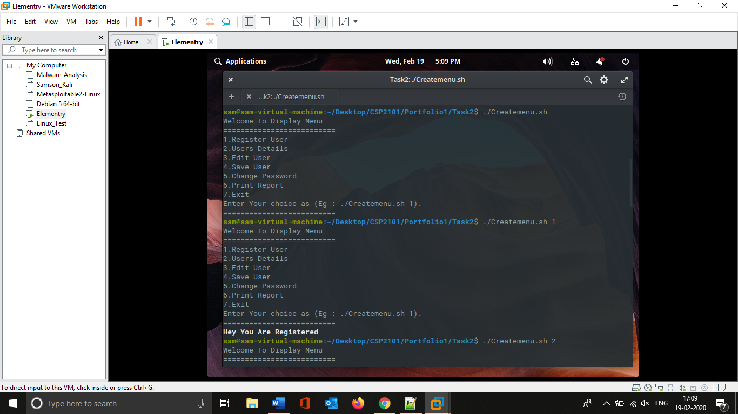

Screenshot 7 Execution

Screenshot 7 shows the result of executing the script without any options.



Screenshot 8 Checking with option 1

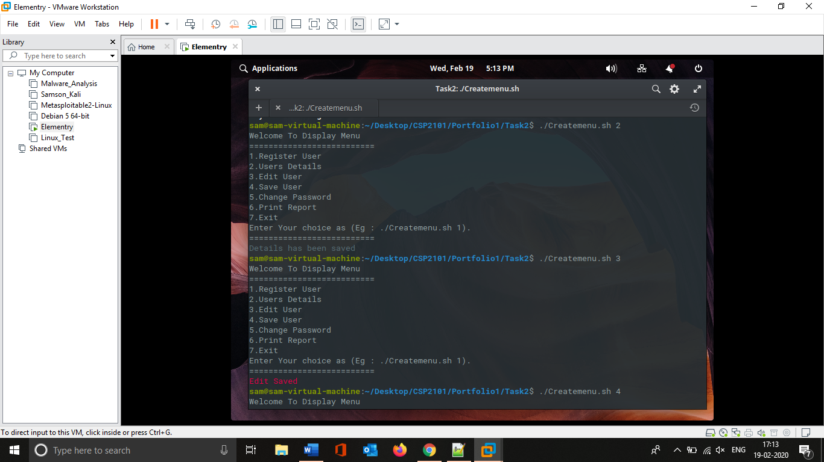

Screenshot 9 Checking with option 2



Screenshot 10 Checking with option 3

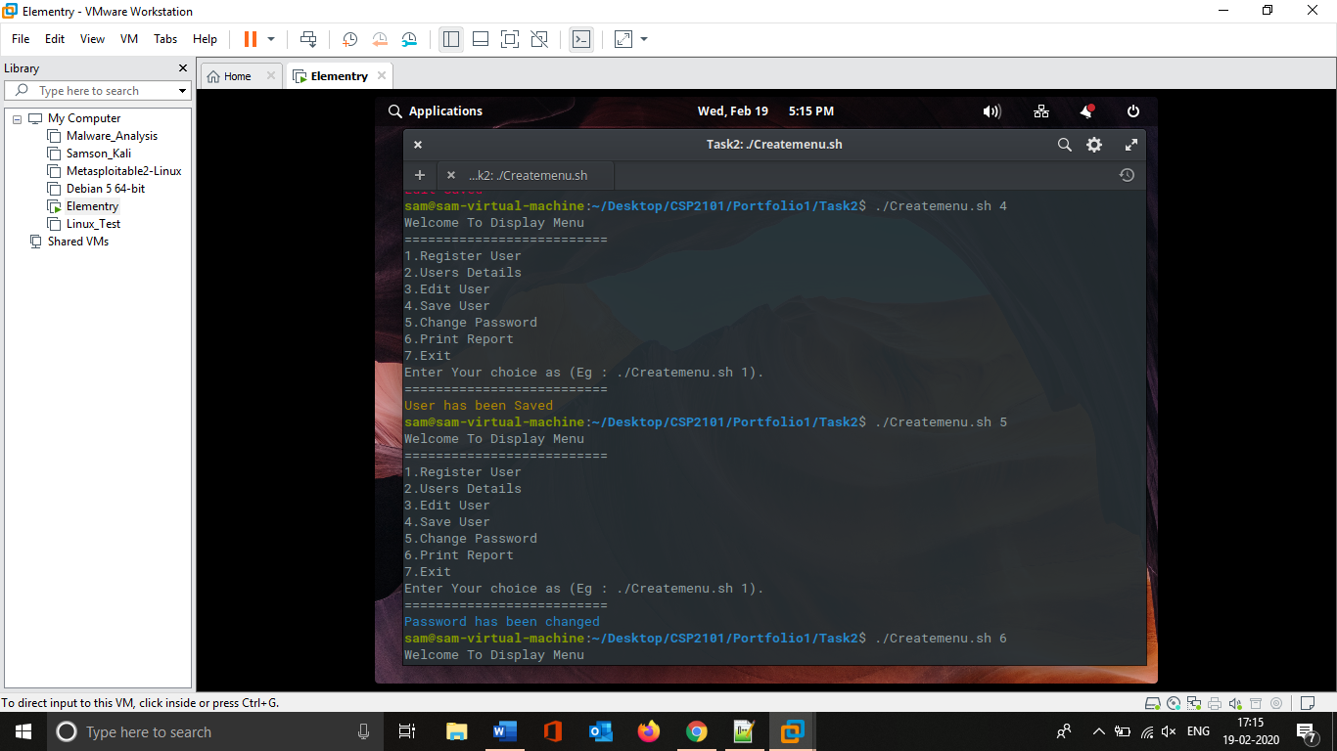

Screenshot 11 Checking with option 4



Screenshot 12 Checking with option 5

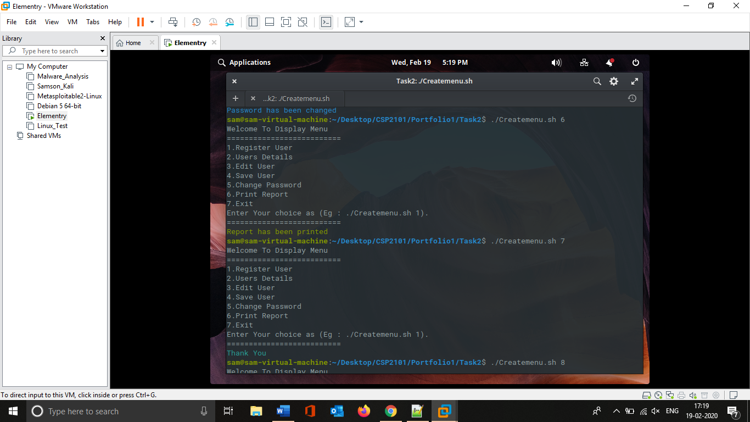

Screenshot 13 Checking with option 6



Screenshot 14 Checking with option 7

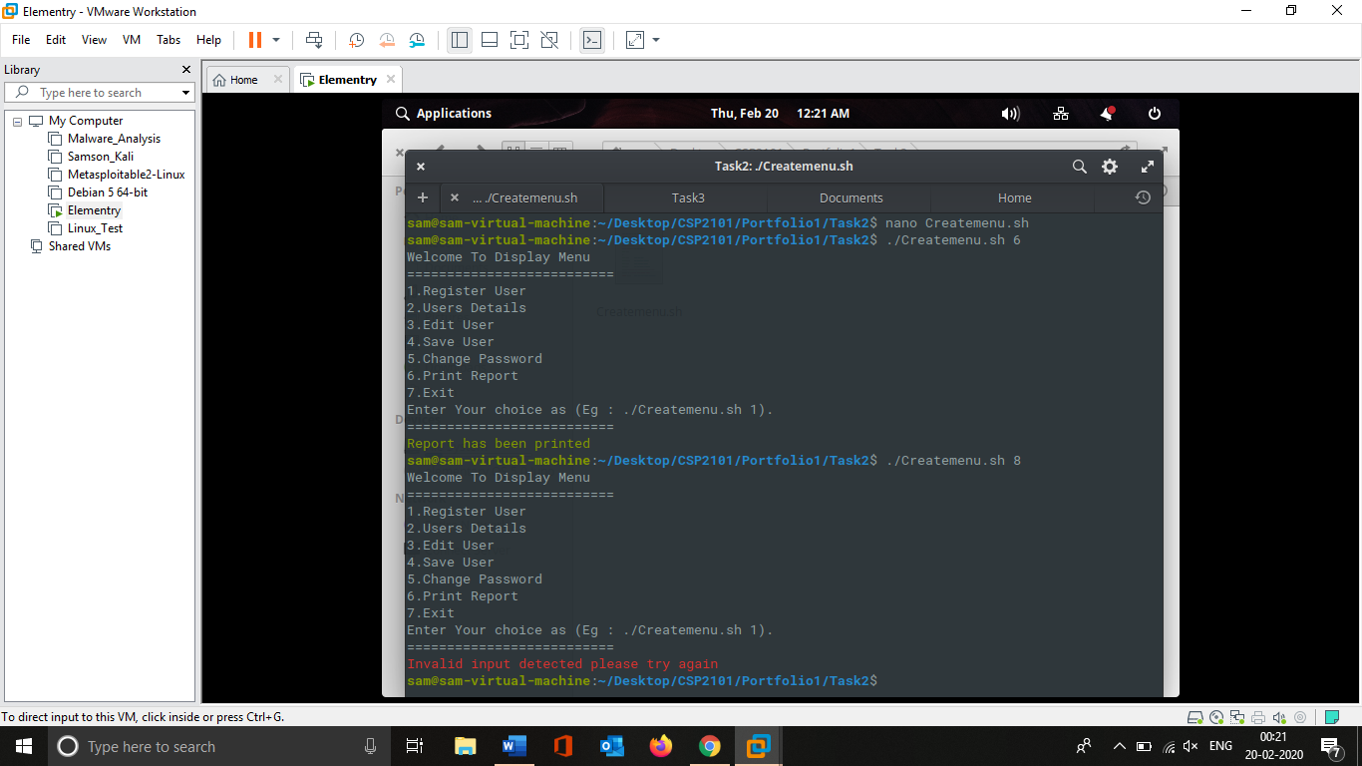

Screenshot 15 Checking with invalid option

Above screenshot shows the execution of script with invalid option. So if the user use the invalid option the script will starts display an alert message.

# Task 3

## Code

#!/bin/bash

# Author : Samson

# Discription : Registration form

# Color Assigning

Red='\033[31m'

Yellow='\033[1;33m'

Green='\033[32m'

# Collecting User input and stroing them in Variables

echo Task 3 Registration Form

read -p "Please enter your Name : " NAME

read -p "Please enter your Date Of Birth : " DOB

read -p "Please enter your Address : " ADDRESS

echo choose your option 1. Red 2.Yellow 3. Green

read -p "Please enter your Desired Color (1/2/3): " COLOR

# checking the condition and execute

# and display user details

if [ "$COLOR" = "1" ]; then

echo -e "${Red}Your Name is $NAME"

echo -e "${Red}$NAME's Date Of Birth = $DOB"

echo -e "${Red}$NAME's Address = $ADDRESS"

echo -e "${Red}$NAME's Desired Color = Red"

elif [ "$COLOR" = "2" ]; then

echo -e "${Yellow}Your Name = $NAME"

echo -e "${Yellow}$NAME's Date Of Birth = $DOB"

echo -e "${Yellow}$NAME's Address = $ADDRESS"

echo -e "${Yellow}$NAME's Desired Color = Yellow"

elif [ "$COLOR" = "3" ]; then

echo -e "${Green}Your Name is $NAME"

echo -e "${Green}$NAME's Date Of Birth = $DOB"

echo -e "${Green}$NAME's Address = $ADDRESS"

echo -e "${Green}$NAME's Desired Color = Green"

fi

exit 0

## Output

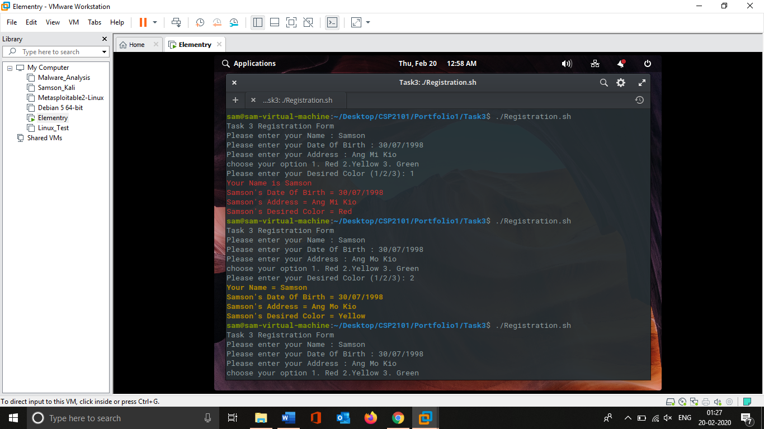

Screenshot Checking with Red colour



Screenshot Checking with Yellow colour

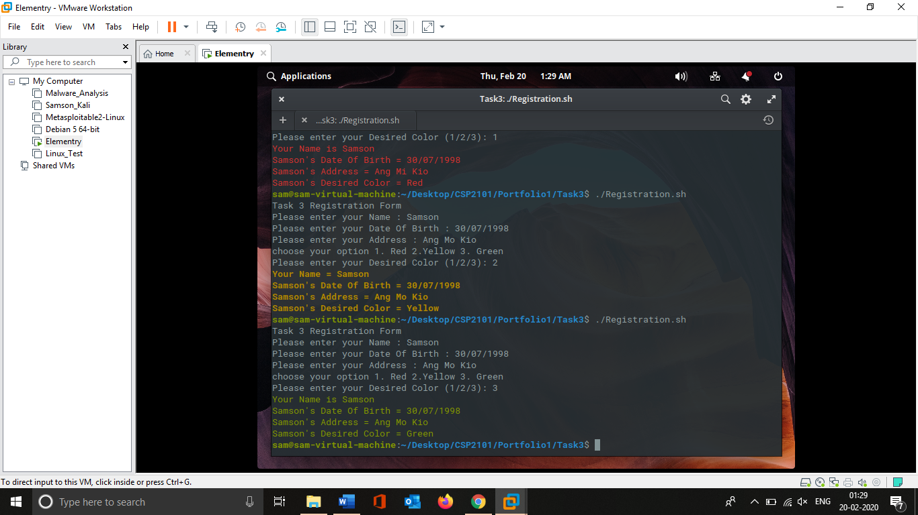

Screenshot Checking with green colour